Preview of some of the inspectdf output graphs

I like this package because it’s got a lot of functionality and it’s incredibly straightforward to use. In short, it allows you to understand and visualize column types, sizes, values, value imbalance & distributions as well as correlations. Better yet, you can run each of these features for an individual data frame, or compare the differences between two data frames.

**Set Up**

**Install and Load Packages**

Before we get rolling with the tutorial, we need to get our environment ready. Please remember that if you do not have any of the packages already installed, uncomment the installation line by removing the #.

library(devtools)

library(inspectdf)

#install.packages("tidyverse")

library(tidyverse)

#install.packages("readr")

library(readr)

**Download the Data**

We are going to be using the survey data from [data .](https://www.littlemissdata.com/blog/steam-data-art2) Note that there were some issues with survey gathering and therefore you will see some odd values in the data.

#Download the data set

df= read_csv('https://raw.githubusercontent.com/lgellis/STEM/master/DATA-ART-1/Data/FinalData.csv', col_names = TRUE)

**Transform the Data Set**

We will create three data frames for our tutorial.

* **allGrades** is the full data frame with the complete set of survey results
* **oldGrades** includes a subset of the survey results for all grades greater than 5. This includes grades 6-8.
* **youngGrades** includes a subset of the survey results for all grades less than 6. This includes grades 3-5.

We will use allGrades for the single data frame analysis and oldGrades and youngGrades for the data frame comparisons.

allGrades <- df

oldGrades <- allGrades %>%

filter(Grade > 5)

youngGrades <- allGrades %>%

filter(Grade < 6)

#View the distribution of grade to ensure it was split properly

ggplot(oldGrades, aes(x=Grade)) + geom_histogram()

ggplot(youngGrades, aes(x=Grade)) + geom_histogram()

**Run the Package Functions**

For each of the functions, we are going to run it first against the full data frame (allGrades) to view the basic functionality. We will then pass two data frames into the function (oldGrades, youngGrades) to see how the data frame comparison works.

**inspect_types()**

We can use the inspect_types() command to very easily see a breakdown of character vs numeric variables.

inspect_types(allGrades, show_plot = TRUE)

inspect_types(youngGrades, oldGrades, show_plot = TRUE)

**inspect_mem()**

The inspect_mem() function will tell us some basic sizing information, including data frame columns, rows, total size and the sizes of each variable.

inspect_mem(allGrades, show_plot = TRUE)

inspect_mem(youngGrades, oldGrades, show_plot = TRUE)

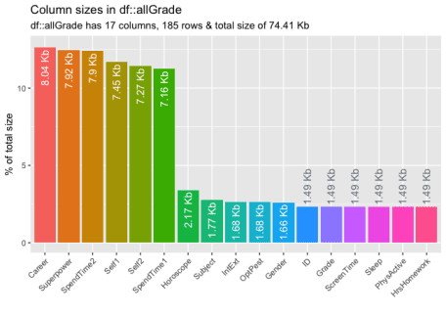

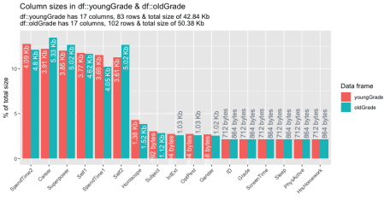

**inspect_na()**

The inspect_na() function shows us the percentage of na values for each variable. The comparison view is quite neat as it highlights variables with unequal na percentages.

inspect_na(allGrades, show_plot = TRUE)

inspect_na(youngGrades, oldGrades, show_plot = TRUE)

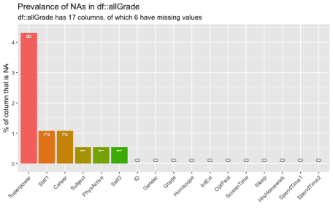

**inspect_num()**

The inspect_num() function shows us the distribution of the numeric variables. The heat plots used for the data frame comparison are pretty cool.

inspect_num(allGrades, show_plot = TRUE)

inspect_num(youngGrades, oldGrades, show_plot = TRUE)

**inspect_imb()**

Similar to the inspect_num() function, the inspect_imb() function allows us to understand the a bit about the value distribution for our categorical values. It shows the most prevalent values for each variable and displays how prevalent they are.

inspect_imb(allGrades, show_plot = TRUE)

inspect_imb(youngGrades, oldGrades, show_plot = TRUE)

**inspect_cat()**

A step further from inspect_imb(), inspect_cat() allows us to visualize the full distribution of our categorical values. Note that if there are a lot of unique values in a particular category, it’s not expected that you should see every value. However, it quite nicely surfaces common values.

inspect_cat(allGrades, show_plot = TRUE)

inspect_cat(youngGrades, oldGrades, show_plot = TRUE)

**inspect_cor()**

We finish off our review with the inspect_cor() function. This allows us to see the Pearson correlation coefficient to see how the variables may relate to one another.

The **Pearson correlation coefficient**, r, can take a range of values from +1 to -1. A value of 0 indicates that there is no association between the two variables. A value greater than 0 indicates a positive association; that is, as the value of one variable increases, so **does** the value of the other variable.

inspect_cor(allGrades, show_plot = TRUE)

inspect_cor(youngGrades, oldGrades, show_plot = TRUE)